# Activity - 5

What does the following code fragment do to the queue q?

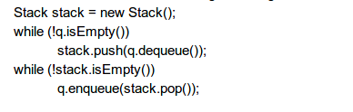

1. First a new stack will be created named stack.
2. When q is not empty items in q are dequeued that means items are removed form q.
3. And they are pushed into the stack.
4. Later when stack is not empty items from the stack are popped and enqueued that means inserted into q.
5. The final output is reverse of q.

For Example :

1. 1 2 3 4 5

|  |  |  |
| --- | --- | --- |
| ENQUEUE(q) | stack.push(q.dequeue()) | OUTPUT |
| Enqueue 0 | - | - |
| Enqueue 1 | - | - |
| Enqueue 2 | - | - |
| Enqueue 3 | - | - |
| Enqueue 4 | - | - |
| Enqueue 5 | - | - |
|  | stack.push(q.dequeue(1)) | 1 |
|  | stack.push(q.dequeue(2)) | 1 2 |
|  | stack.push(q.dequeue(3)) | 1 2 3 |
|  | stack.push(q.dequeue(4)) | 1 2 3 4 |
|  | stack.push(q.dequeue(5)) | 1 2 3 4 5 |
| - | q.enqueue(stack.pop(5)) | 5 |
| - | q.enqueue(stack.pop(4)) | 5 4 |
|  | q.enqueue(stack.pop(3)) | 5 4 3 |
|  | q.enqueue(stack.pop(2)) | 5 4 3 2 |
|  | q.enqueue(stack.pop(1)) | 5 4 3 2 1 |